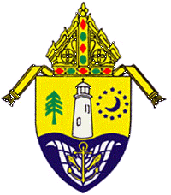
Catholic Diocese of Biloxi

Blessing of Holy Oils
Exploring the meaning
through prayer and reflection
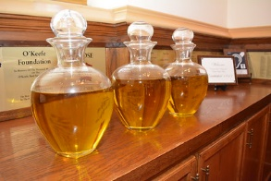

Suggestions for using this resource
The following pages contain the prayers used to bless the oils of the Sick and Catechumens and to consecrate the Oil of Chrism during the Chrism Mass.
It is within the liturgy and its prayers that the meaning of the Church’s ministry with the sick, of initiation, of ordination and consecration is revealed.
You are invited to pray these prayers and reflect on them, listening for the wisdom and understanding they carry.
When this prayer and reflection take place in groups, the focus of the sharing is reflection and conversation rather than debate.
The following process is suggested:
• Choose which blessing prayer you are going to focus on.
• Create or enter a space conducive to prayer and reflection.
• Settle and ready yourself for prayer. Remember the presence of God and the movement of the Holy Spirit within you and around you.
• Pray the prayer you have chosen, perhaps using a lectio divinia method. The questions below may help your reflection.
• If you are reflecting in a group take time to share your insights, listening for the differences which expand your own understanding.
• As a member of the Church, and in the light of your prayer and reflection, to what action or commitment do you feel the Holy Spirit calling you?
• Be still. What prayer does this reflection lead you to make?
• If you are reflecting in a group, some people may like to share their prayer to bring the time of prayer and reflection to a close.
Some questions:
- What does this text reveal to you of:
  - God and God’s mission and hopes for the world and humanity?
  - the Church community?
  - the ministry for which the oil is used?
- What does the ritual surrounding the blessing of the oil reveal to you? How does it add to your understanding?
- What do you hear God saying to you in this prayer?
- What is God revealing to you about your life as a disciple?

Let us continue to pray for all people and ministries who will use or receive these holy oils.
2 | P a g e

The Holy Oils
Each year during Holy Week we come together as the Church of the Diocese of Biloxi, Mississippi, led by our Bishop, to celebrate the Mass of the Chrism.
The OIL OF CHRISM is consecrated at this Mass. This Oil will be used for baptisms and confirmations, for ordinations of priests and bishops, and for the dedication of churches and altars.
During this Mass we also bless the OIL OF CATECHUMENS, mindful of our Elect and catechumens at whose initiation into the Church it will be used.
We also bless the OIL OF THE SICK, aware of the sick and suffering for whom it will bring comfort and strength.
At this solemn liturgy the priests of the diocese renew the promises of their ordination, renewing their commitment to serve the Church of Biloxi in communion with the Bishop. We also renew our commitment to ministry that is ours through baptism and confirmation.

3 | P a g e

The Chrism Mass
The Chrism Mass begins (usually at 10:30 a.m. on Tuesday of Holy Week in the Biloxi Diocese) with the entrance procession which includes the priests of the diocese and the bishop.
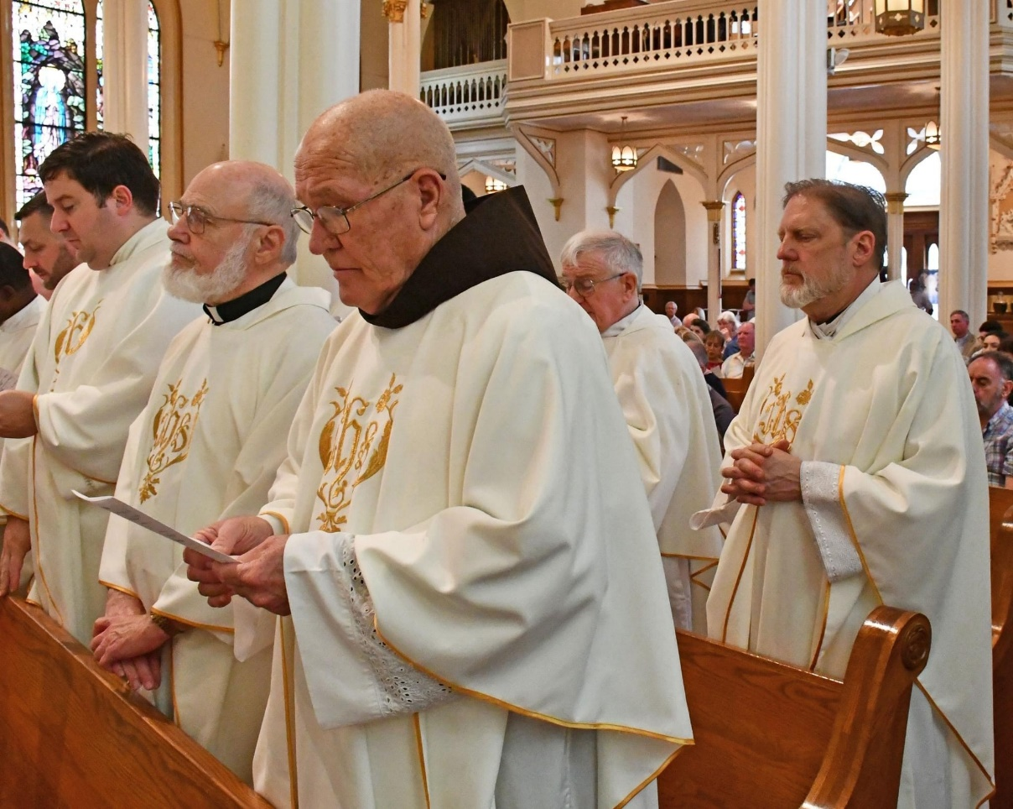
After the Introductory Rite and the Liturgy of the Word are completed and after the Homily, the priests of the Diocese of Biloxi stand and profess their commitment in the following manner:
Renewal of Commitment to Priestly Service
Bishop: Beloved sons, on the anniversary of that day when Christ our Lord conferred his priesthood on his Apostles and on us, are you resolved to renew, in the presence of your Bishop and God’s holy people, the presence of your Bishop and God’s holy people, the promises you once made?
4 | P a g e
Priests: I am.
Bishop: Are you resolved to be more united with the Lord Jesus and more closely conformed to him, denying yourselves and confirming those promises about sacred duties towards Christ’s Church which, prompted by love of him, you willingly and joyfully pledged on the day of your priestly ordination?
Priests: I am.
Bishop: Are you resolved to be faithful stewards of the mysteries of God in the Holy Eucharist and the other liturgical rites and to discharge faithfully the sacred office of teaching, following Christ the Head and Shepherd, not seeking any gain, but moved only by zeal for souls?
Priests: I am.
Bishop: (Addressing the Assembly)
As for you, dearest sons and daughters, pray for your Priests, that the Lord may pour out his gifts abundantly upon them and keep them faithful as ministers of Christ, the High Priest, so that they may lead you to him, who is the source of salvation.
People: Christ, hear us. Christ, graciously hear us.
Bishop: And pray also for me, that I may be faithful to the apostolic office entrusted to me in my lowliness and that in your midst I may be made day by day a living and more perfect image of Christ, the Priest, the good Shepherd, the Teacher and the Servant of all.
People: Christ, hear us. Christ, graciously hear us.
Bishop: May the Lord keep us all in his charity and lead all of us, shepherds and flock, to eternal life.
All: Amen

5 | P a g e

Blessing of the Oils and Consecrating of the Chrism
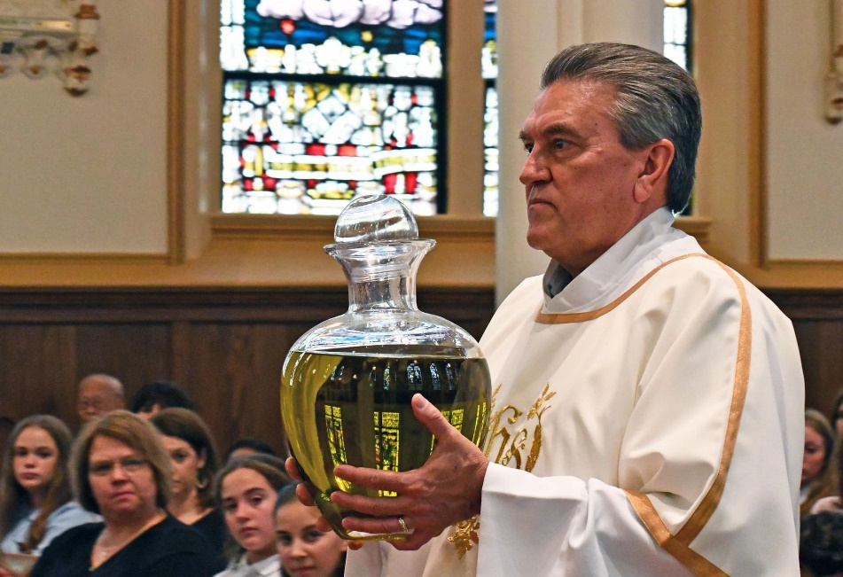
The diocese’s large jars of olive oil are brought forward in procession to tables prepared before the altar in the sanctuary for each jar. (Usually deacons of the diocese carry the oil jars and set them on the tables.)

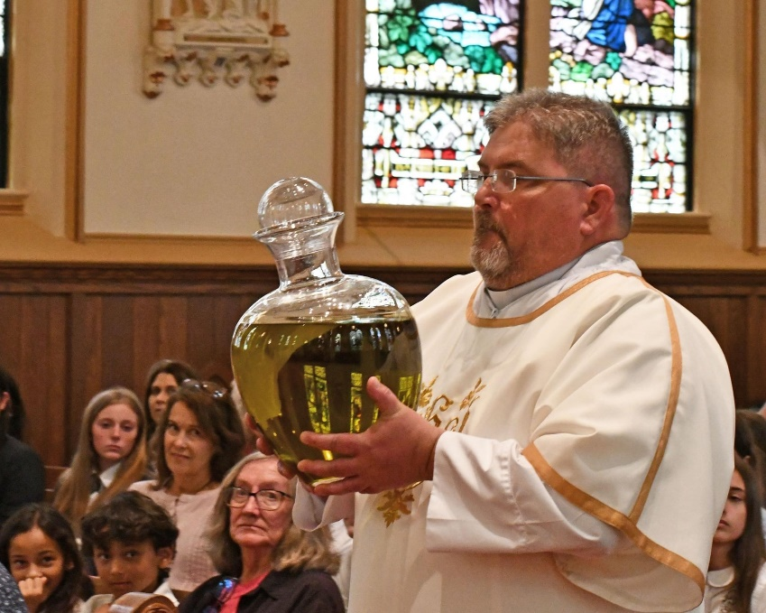

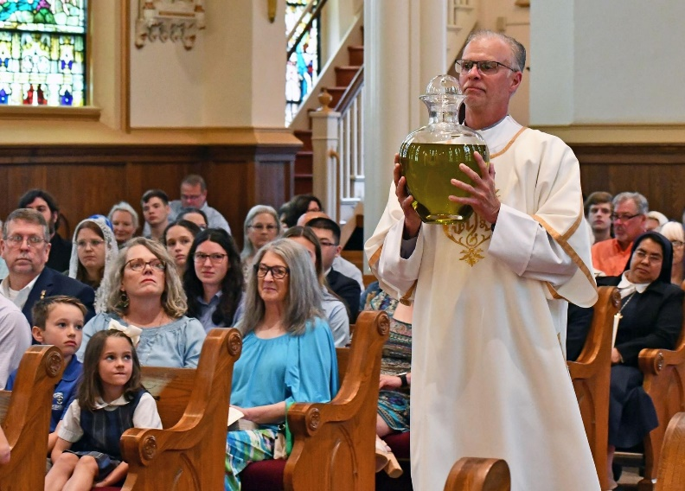

6 | P a g e
The priests of the diocese join the bishop around the altar to participate in the blessing of the oils.
Blessing of the Oil of the Sick
Bishop: O God, Father of all consolation, who willed to heal the infirmities of the weak through your Son, listen favorably to the prayer of faith: send forth from the heavens, we pray, your Holy Spirit, the Paraclete, upon this oil in all its richness, which you have graciously brought forth from the verdant tree to restore the body, so that by your holy blessing + everyone anointed with this oil as a safeguard for body, soul, and spirit may be freed from all pain, all infirmity, and all sickness. May your holy oil, O Lord, be blessed by you for our sake in the name of Jesus Christ our Lord, who lives and reigns with you for ever and ever.
All: Amen.
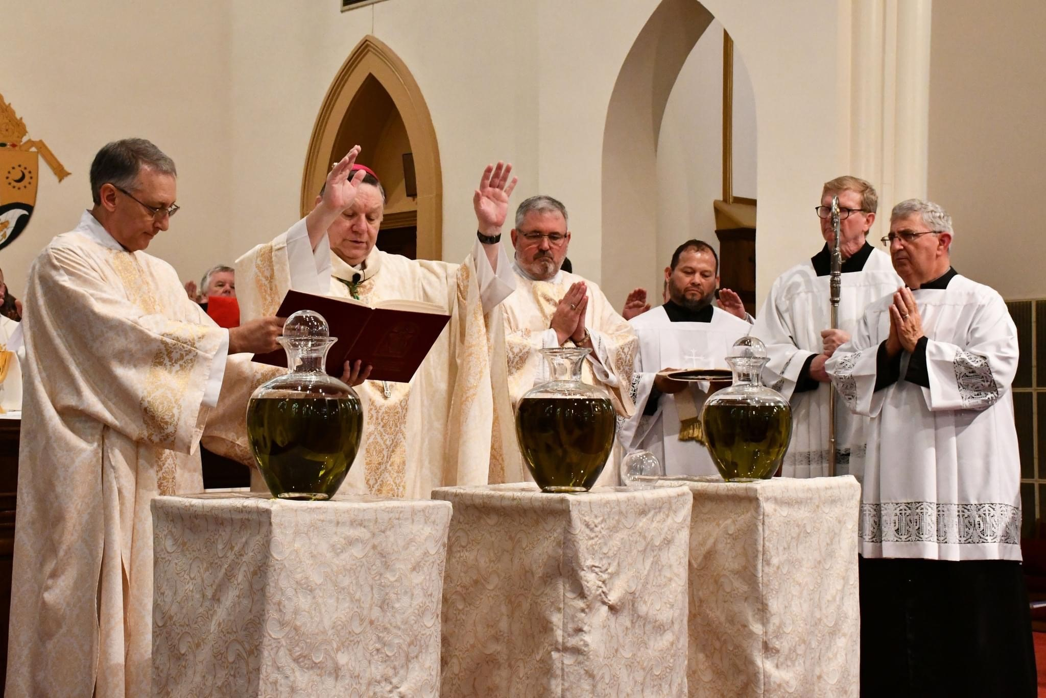
7 | P a g e
Blessing of the Oil of Catechumens
Bishop: O God, strength and protection of your people, who have made the oil you created a sign of strength, graciously bless + this oil, and grant courage to the catechumens who will be anointed with it, so that, receiving divine wisdom and power, they may understand more deeply the Gospel of your Christ, they may undertake with a generous heart the labors of the Christian life, and, made worthy of adoption as your sons and daughters, they may rejoice to be born anew and to live in your Church. Through Christ our Lord.
All: Amen.
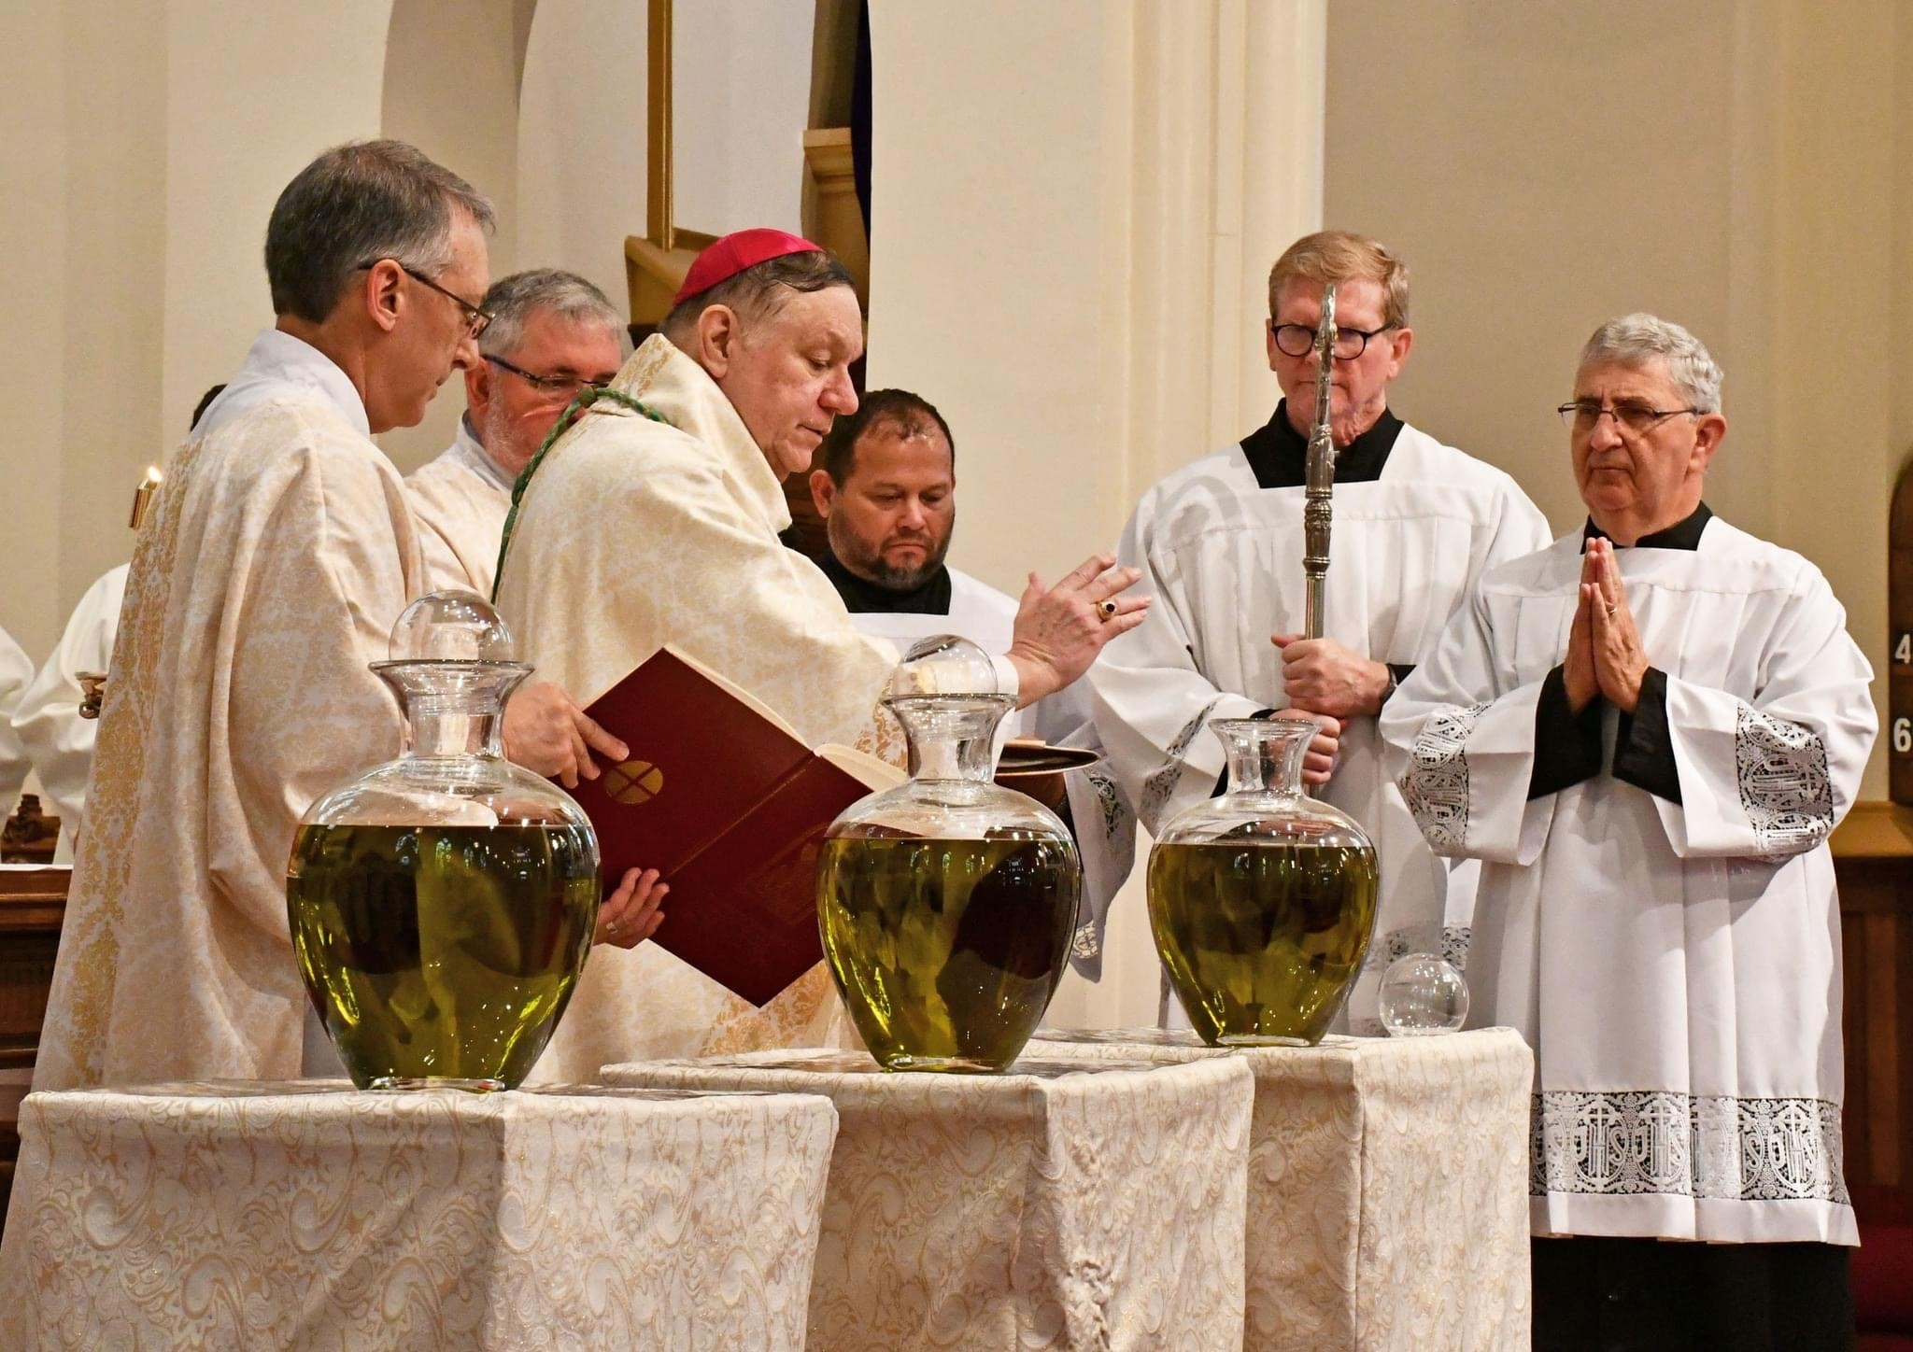

8 | P a g e
Consecration of the Chrism
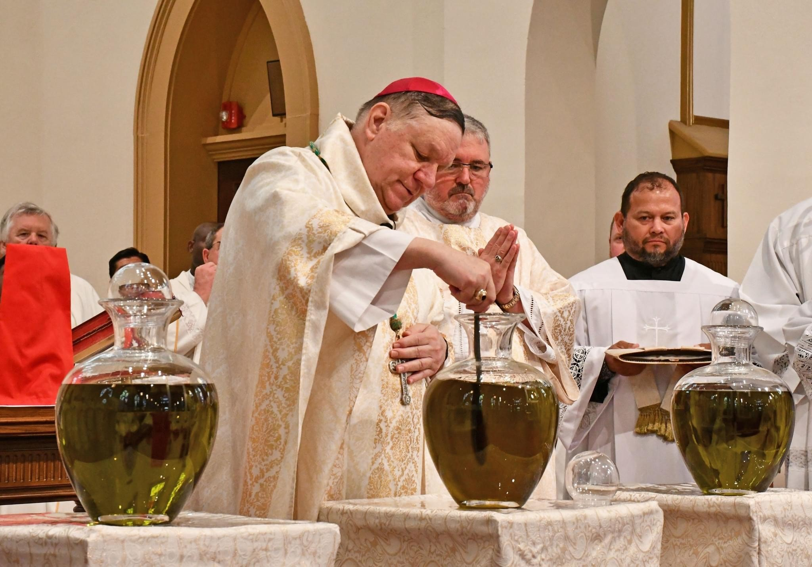
Following the blessing of the Oil of Catechumens, the bishop goes to the Oil of Chrism and adds the perfume to the oil in silence.

After this is done, he says the invitation to prayer:
Bishop: Let us pray, dear brothers and sisters, to God the almighty Father, that he bless and sanctify this oil, so that all who are outwardly anointed with it may be inwardly transformed and come to share in eternal salvation.

9 | P a g e
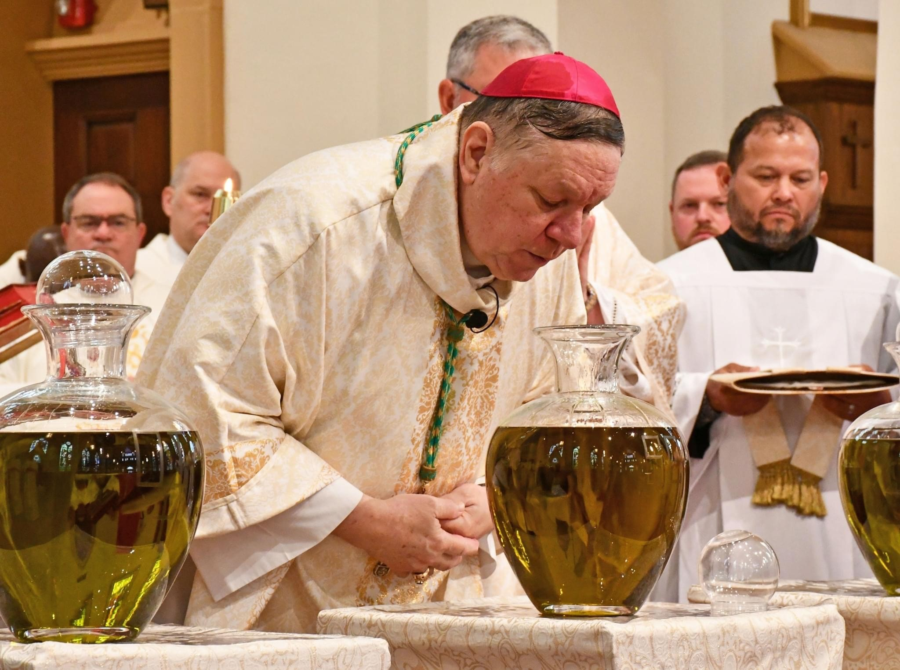
The Bishop breathes over the Oil of Chrism. Then extending his arms over the Oil, he continues with the Prayer of Consecration:
O God, author of all growth and spiritual progress, receive in your goodness the grateful homage that the Church joyfully offers to you through our voice. For in the beginning you commanded the earth to bring forth fruit-bearing trees, among which olive trees would arise as providers of this most rich oil, so that their fruit might serve for sacred Chrism. In the spirit of prophecy, David foresaw the sacraments of your grace and sand of the oil that would gladden our faces. After the world’s offenses were washed away by the flood, a dove announced the restoration of peace on earth with the olive branch, foreshadowing the gift to come. In the last days all this has been clearly revealed: when every offense is removed through the waters of Baptism, the anointing with this oil causes our faces to be joyful and serene.
10 | P a g e

You also commanded your servant Moses to make his brother Aaron a priest, by pouring this oil upon him after he had been washed in water. Still greater dignity was added to this when your Son Jesus Christ, our Lord, insisted that he be washed by John in the waters of the Jordan: you sent the Holy Spirit from on high in the likeness of a dove; you declared by the witness of the voice that followed, that you were well pleased in him, your Only Begotten Son; and you were seen to confirm clearly what the prophet David had foretold in song, that Christ would be anointed with the oil of gladness above his companions.
The concelebrating Priests extend their right hands over the Oil of Chrism in silence as the Bishop continues:
Therefore we beseech you, Lord: be pleased to sanctify with your + blessing this oil in its richness, and to pour into it the strength of the Holy Spirit, with the powerful working of your Christ. From his holy name it has received the name of Chrism, and with it you have anointed your priests, prophets, kings, and martyrs. May you confirm the Chrism you have created as a sacred sign of perfect salvation and life for those to be made new in the spiritual waters of Baptism. May those formed into a temple of your majesty by the holiness infused through this anointing and by the cleansing of the stain of their first birth be made fragrant with the innocence of a life pleasing to you. May those anointed with royal, priestly, and prophetic dignity be clothed with the garment of an incorruptible gift in keeping with the Sacrament you have established. May this oil be the Chrism of salvation for those born again of water and the Holy Spirit, and may it make them partakers of eternal life and sharers of heavenly glory. Through Christ our Lord.
All: Amen.

11 | P a g e

The jars of oil are taken out of the sanctuary to a room in the rectory to be divided up into small bottles for each parish priest and for each Deanery in the Diocese of Biloxi to be used for the year.
The Mass continues with the Liturgy of the Eucharist …

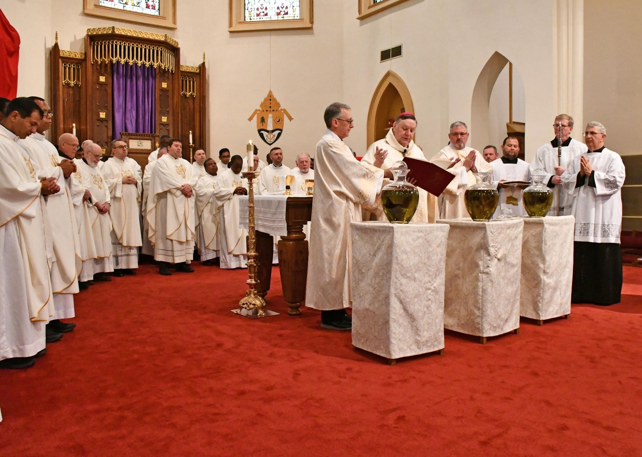

(Special thanks for permission to use their document, granted by Louise Gannon, RSJ;
Manager Worship and Prayer – Pastoral Ministries, DIOCESE OF MAITLAND – NEWCASTLE)

12 | P a g e

